**REACT JS**

React is developed by the Facebook.

React will work on two methods which are Class Based and Functional Based.

React is Very helpful to create SPA (Single Page Applications) by using the JavaScript Libraries.

React Creates the Virtual Dom in Memory.

**Components**

Components is a nothing a particular piece of code which can be reusable in the project.  
Components are two types which are class component and functional component.

Examples for the functional components

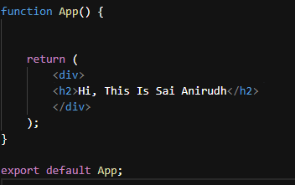

Here we can create multiple components  
  
**Nested Component**

In nested components, multiple functions are defined within a single file. These functions are then utilized within another function or component.

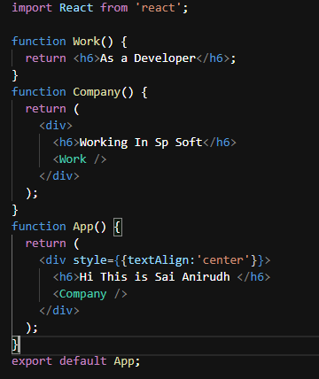

**Stateless Functional Component**

In a stateless functional component, we cannot manage internal state, but we can access data passed down from parent components through props.

const Number = ({ count }) => {

return <h2>The Count is {count}</h2>;

};

**State full Functional Component**

In a state full functional component, we can declare the state values and we can store and handle the state values

import React, { useState } from 'react';

const Counter = () => {

const [count, setCount] = useState(0);

const incrementCount = () => {

setCount(prevCount => prevCount + 1);

};

const decrementCount = () => {

setCount(prevCount => prevCount - 1);

};

return (

<div>

<h2>Counter</h2>

<p>Count: {count}</p>

<button onClick={incrementCount}>Increment</button>

<button onClick={decrementCount}>Decrement</button>

<Number count={count} />

</div>

);

};

export default Counter;

**Higher Order Component**

HOC is function that takes a component as an input and returns a new component with additional functionality.

Here I am taking that validation for login

HOC.Jsx

import React from 'react';

function HOC(Component) {

return class extends React.Component {

render() {

const { auth } = this.props;

if (auth) {

return <div>Please login</div>;

}

return (

<div>

<Component name='Anirudh' />

</div>

);

}

};

}

export default HOC;

in here if the auth is false its return please login if it the auth is true it returns as   
Hi Welcome Anirudh here I am send my name through props

App.jsx

import React from 'react'

import HOC from './hoc'

function App(props) {

return (

<div>

<h1>Hi Welcome {props.name}</h1>

</div>

)

}

export default HOC(App)

**Day -2**

**Props**

It is the concept of the passing the data from Parent Component to Child Component.

The data will be one-way process that means the data will receive to child component from that particular parent component.

**Passing Props:** Props are passed from parent components to child components. Parent components can pass data or functions as props to their children when they are being rendered.

**Receiving Props:** Child components receive props as arguments to their functional component or as properties of the this. Props object in class components.

**Immutable Data:** Props are immutable, meaning they cannot be modified by the child component. They are read-only within the component that receives them.

**Component Customization:** Props allow components to be customizable and reusable. By passing different props, you can render the same component in different ways with different data.

// FormComponent.js

import React from 'react';

const FormComponent = ({ formData, onInputChange, onSubmit }) => {

  return (

    <form onSubmit={onSubmit}>

      <div>

        <label>Username:</label>

        <input type="text" name="username" value={formData.username} onChange={onInputChange} />

      </div><div>

<label>Password:</label>

        <input type="password" name="password" value={formData.password} onChange={onInputChange} />

      </div>

      <button type="submit">Submit</button>

    </form>

  );

}

export default FormComponent;

// ParentComponent.js

import React, { useState } from 'react';

import FormComponent from './FormComponent';

const ParentComponent = () => {

  const [formData, setFormData] = useState({

    username: '', password: ''   });

  const handleSubmit = (e) => {

    e.preventDefault();

    // Handle form submission logic

    console.log('Form submitted:', formData);

  };

  const handleInputChange = (event) => {

    // Update form data in parent component state

    setFormData({

      ...formData,

      [event.target.name]: event.target.value

    });

  };

  return (

    <div>

      <FormComponent formData={formData} onInputChange={handleInputChange} onSubmit={handleSubmit}/>

      <h1>Username = {formData.username} and Password = {formData.password} are the values entered in the fields.</h1>

    </div>

  ); }

export default ParentComponent;

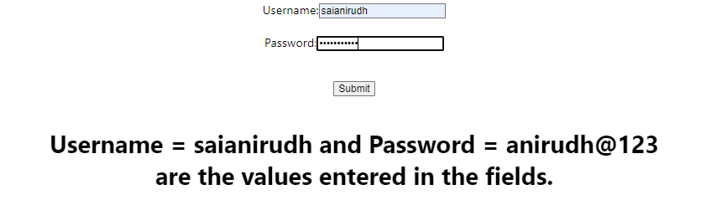

In the Parent Component, we initialize a state variable formData using useState, providing default values for username and password. We define functions handleSubmit and handleInputChange to manage form submission and input changes, respectively. The FormComponent receives these state variables and functions as props to handle form rendering, input changes, and submission.

**Use State**

UseState is the Hook, that allows us to track state in a function component.

import React, { useState } from 'react';

const Counter = () => {

  // Define a state variable 'count' initialized to 0

  const [count, setCount] = useState(0);

  return (

    <div>

        <center>

            <h2>Count: {count}</h2>

            {/* Button to increment the count */}

            <div style={{display:'flex', justifyContent:'space-around'}}>

                <button style={{padding:'10px 20px',fontSize:'20px'}} onClick={() => setCount(count + 1)}>Increment</button>

                <button  style={{padding:'10px 20px',fontSize:'20px'}} onClick={() => setCount(count - 1)}>Decrement</button>

                <button  style={{padding:'10px 20px',fontSize:'20px'}} onClick={() => setCount(0)}>Reset</button>

            </div>

        </center>

    </div>

  );

}

export default Counter;

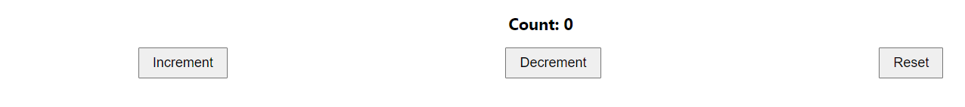

const [Count, setCount] = useState ()

setCount is a function provided by the useState hook. It is used to update the state variable Count.

useState () is called without an initial value. This means that the initial state of Count will be undefined. It's generally recommended to provide an initial value to useState () for better predictability of your component's behavior.

**Use Effect**

useEffect is another React Hook used for managing side effects in functional components. Side effects are actions that occur outside the scope of the component, such as data fetching, DOM manipulation, or subscriptions.

The useEffect Hook allows you to perform side effects in your components.

useEffect accepts two arguments. The second argument is optional.

useEffect(<function>, <dependency>)

import { useState, useEffect } from "react";

function Counter1() {

  const [count, setCount] = useState (0);

  const [calculation, setCalculation] = useState(0);

  useEffect (() => {

    setCalculation(() => count * 2);

  }, [count]); // <- add the count variable here

  return (

    <div style={{marginTop:'10%'}}>

        <center>

            <h1>Count: {count}</h1>

            <button style={{padding:'10px 20px',fontSize:'20px'}} onClick={() => setCount((c) => c + 1)}>Add Number</button>

            <h1>Calculation: {calculation}</h1>

        </center>

    </div>

  );

}

export default Counter1;

useEffect Hook that is dependent on a variable. If the count variable updates, the effect will run again.

**Use Context:**

useContext is a React Hook that provides a way to consume context within a functional component. Context in React is a mechanism for passing data through the component tree without having to pass props manually at every level.

import React, { useState, useContext } from 'react';

const ThemeContext = React.createContext();

const ThemeProvider = ({ children }) => {

  const [theme, setTheme] = useState('light');

  const toggleTheme = () => {

    setTheme(prevTheme => (prevTheme === 'light' ? 'dark' : 'light'));

  };

  return (

    <ThemeContext.Provider value={{ theme, toggleTheme }}>

      {children}

    </ThemeContext.Provider>

  );

};

// Component consuming the context value

const ThemeConsumer = () => {

  const { theme } = useContext(ThemeContext);

  return (

    <div style={{ backgroundColor: theme === 'light' ? '#f0f0f0' : '#333', color: theme === 'light' ? '#333' : '#f0f0f0', padding: '20px', margin: '20px 0' }}>

      <p>Current Theme: {theme}</p></div>

  );

};

// App component

const App = () => {

  return (

    <div style={{marginTop:'20px',marginBottom: '40px'}}>

          <center>

              <ThemeProvider>

                  <div>

                      <h1>Theme Change Example</h1>

                      <ThemeConsumer />

                      <ThemeToggler />

                  </div></ThemeProvider></center>

    </div>

  );};

// Component to toggle theme

const ThemeToggler = () => {

  const { toggleTheme } = useContext(ThemeContext);

  return (

    <button style={{padding:'10px 20px'}} onClick={toggleTheme}>Change Theme</button>

  );

};

export default App;

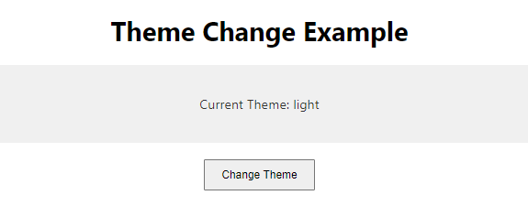

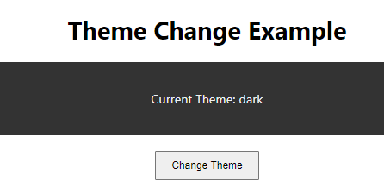

The ThemeProvider component manages the theme state and provides it to its children via context. The ThemeConsumer component consumes the theme value and renders accordingly. Finally, the ThemeToggler component allows toggling between light and dark themes by invoking the toggleTheme function obtained from the context.